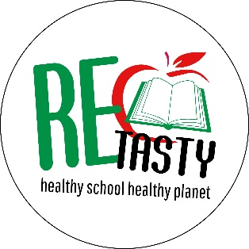

**RE-TASTY**

**R**esearch - **T**ransformative **A**ctions **T**ogether with **Y**outh

**Implementation Plan**

|  |  |
| --- | --- |
| **Lesson 1 -**  **a) Citizen science and food education**  **b) Formulation of sub-research question**  1 hour (minimum) - 1.5 hour (ideal)  Activity in class | Fun intro activity with the students  What is citizen science and how it relates to education?  What is RE-TASTY and what are the main steps of this research project?  What does healthy and sustainable food at school mean for you as students?  What are the main problems that you, as students, face today in relation to the food you eat at school? Discussion based on the Whole School Approach (WSA) framework  Formulation of sub-research question by the students (the question can be focused on a food aspect with which the students relate to, depending on the area they live) |
| **Lesson 2 – Preparation for data collection – How? When?**  1 hour (minimum) - 1.5 hour (ideal)  Activity in class (could be on the same day as lesson 1 or a bit later) | HOW:  Presentation of basic questionnaire which students will then co-create by adding their own questions  WHO/WHEN:  Decide who will interview whom and when  Description on data collection procedure  Strategies for data collection and ethics – check list discussed with students |
| **Data collection by the students (2 hours)**  Activity at their own time (about 2 weeks) | Data collection by the students  The students will use the questionnaire in Google Form to collect their data (about 3 interviews per student). Students can work in pairs.  On submission (after each interview), the completed forms will come to the project coordinator who will do a primary analysis of the data and then bring the data in class to finish the analysis with the students. |
| **Lesson 3 – Data analysis interpretation**  1 hour (minimum) - 1.5 hour (ideal)  Activity in class – 2 weeks after lesson 2 | Final data analysis with students and data interpretation  Preparation of a summary of main research results  Decision and design of action |
| **Action by the students** (depending on the time students/staff have available)  Activity at their own time (2-3 weeks) | Implement the action decided in the class |
| **Lesson 4 – Reflection on the action**  (1 hour) | Reflection on the action |

.